

Excel Assignment - 10

1. See the below picture and create the exact table with exact formatting. Font – ‘Times New Roman’ Size – 14, Color of first line Orange.

|  |  |  |  |  |  |  |  |
| --- | --- | --- | --- | --- | --- | --- | --- |
| **Roll No.** | **Name of the student** | **Sub-1** | **Sub-2** | **Sub-3** | **Sub-4** | **Sub-5** | **Sub-6** |
| 100101 | Rohan | 72 | 55 | 52 | 69 | 95 | 32 |
| 100102 | Mohan | 65 | 51 | 63 | 85 | 71 | 69 |
| 100103 | Ravi | 72 | 56 | 78 | 85 | 47 | 68 |
| 100104 | Ruby | 68 | 71 | 85 | 84 | 78 | 60 |
| 100105 | Radhika | 80 | 78 | 58 | 65 | 68 | 45 |
| 100106 | Rakhi | 61 | 78 | 45 | 62 | 75 | 64 |
| 100107 | David | 78 | 69 | 96 | 52 | 63 | 87 |
| 100108 | Monika | 96 | 85 | 86 | 84 | 45 | 63 |
| 100109 | Tommy | 75 | 63 | 54 | 63 | 61 | 98 |
| 100110 | Rakesh | 63 | 52 | 96 | 87 | 78 | 45 |

Answer:

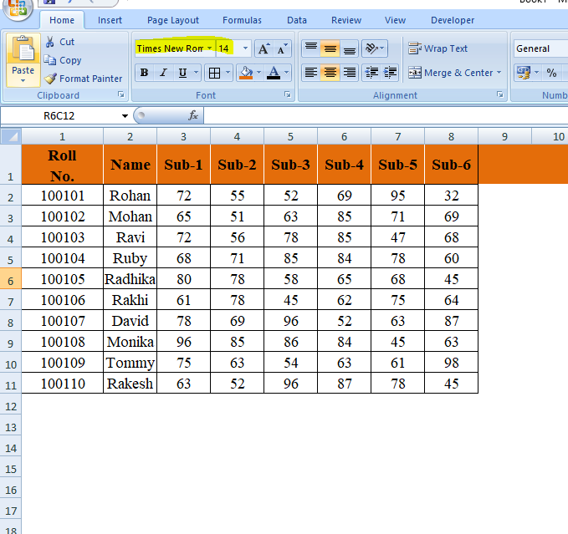

1. From the above table use Sum Formula and find the total for each student.

Answer:

|  |  |  |
| --- | --- | --- |
| **Roll  No.** | **Name** | **Total** |
| 100101 | Rohan | 375 |
| 100102 | Mohan | 404 |
| 100103 | Ravi | 406 |
| 100104 | Ruby | 446 |
| 100105 | Radhika | 394 |
| 100106 | Rakhi | 385 |
| 100107 | David | 445 |
| 100108 | Monika | 459 |
| 100109 | Tommy | 414 |
| 100110 | Rakesh | 421 |

1. Calculate Average for each student in the next row. Use Formulas.

Answer:

|  |  |  |
| --- | --- | --- |
| **Roll  No.** | **Name** | **Average** |
| 100101 | Rohan | 62.5 |
| 100102 | Mohan | 67.333 |
| 100103 | Ravi | 67.667 |
| 100104 | Ruby | 74.333 |
| 100105 | Radhika | 65.667 |
| 100106 | Rakhi | 64.167 |
| 100107 | David | 74.167 |
| 100108 | Monika | 76.5 |
| 100109 | Tommy | 69 |
| 100110 | Rakesh | 70.167 |

1. Calculate Rank for each student. Use Formulas.

Answer:

|  |  |  |  |
| --- | --- | --- | --- |
| **Roll  No.** | **Name** | **Total** | **Rank** |
| 100101 | Rohan | 375 | 10 |
| 100102 | Mohan | 404 | 7 |
| 100103 | Ravi | 406 | 6 |
| 100104 | Ruby | 446 | 2 |
| 100105 | Radhika | 394 | 5 |
| 100106 | Rakhi | 385 | 5 |
| 100107 | David | 445 | 2 |
| 100108 | Monika | 459 | 1 |
| 100109 | Tommy | 414 | 2 |
| 100110 | Rakesh | 421 | 1 |

1. Calculate Percentage for each student. Use Formulas. Round off the decimals up to 2 points.

Answer:

|  |  |  |  |
| --- | --- | --- | --- |
| **Roll  No.** | **Name** | **Total** | **Percent** |
| 100101 | Rohan | 375 | 62.50% |
| 100102 | Mohan | 404 | 67.33% |
| 100103 | Ravi | 406 | 67.67% |
| 100104 | Ruby | 446 | 74.33% |
| 100105 | Radhika | 394 | 65.67% |
| 100106 | Rakhi | 385 | 64.17% |
| 100107 | David | 445 | 74.17% |
| 100108 | Monika | 459 | 76.50% |
| 100109 | Tommy | 414 | 69.00% |
| 100110 | Rakesh | 421 | 70.17% |